St Johns Apparel Order Form
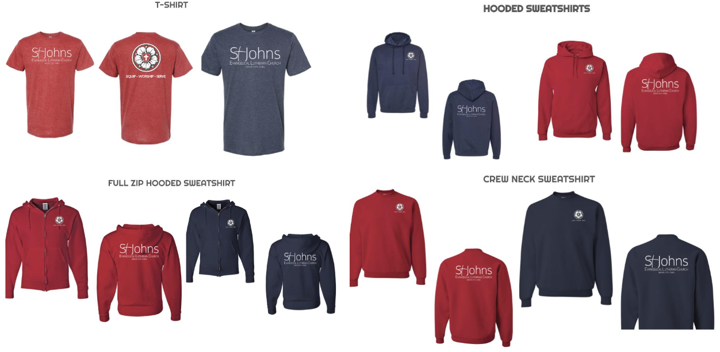

PLEASE MARK QUANTITY UNDER EACH DESIRED SIZE

T-SHIRTS - YOUTH S - ADULT XL= $15 / 2XL – 4XL= $17
 | YS | YM | YL | S | M | L | XL | 2XL | 3XL | 4XL
Red
Blue

HOODED SWEATSHIRT - YOUTH S - ADULT XL = $25 / 2XL = $27 / 3XL, 4XL = $30
 | YS | YM | YL | S | M | L | XL | 2XL | 3XL | 4XL
Red
Blue

FULL ZIP HOODED SWEATSHIRT - ADULT S - XL = $28 / 2XL = $30 / 3XL, 4XL = $32
 | S | M | L | XL | 2XL | 3XL | 4XL
Red
Blue

CREWNECK SWEATSHIRT - YOUTH S -ADULT XL = $20 / 2XL – 4XL = $25
 | YS | YM | YL | S | M | L | XL | 2XL | 3XL | 4XL
Red
Blue

NAME: PHONE NUMBER:
TOTAL PRICE: PAYMENT METHOD: CASH / CHECK / CARD (ONLINE)
Please add “T-Shirt” to the memo of your check or online giving so we know where the money should go. Order forms should be turned in with your offerings or dropped off in the office by December 3rd.
Proceeds benefit the 2024 Mexico Missions Trip.

