CHRISTMAS POINSETTIA SALE

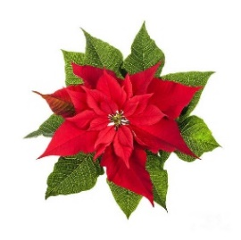
As in previous years, the Sanctuary of St. John’s will be filled with the beauty of red poinsettias as we celebrate the coming of the Christ Child. Each plant will be in a 6.5-inch pot and is available for purchase. The cost of each poinsettia will be $8.00. You may place an order by sending a completed form along with your payment to the office, or placing it in the offering plate. Make checks payable to St. John’s and mark “For Poinsettia Order.” Orders must be received no later than Friday, December 15th. The flowers may be taken after our Christmas service on December 25th.

Please check one:
___ I will be picking my flowers up by December 30th.
___ I wish to donate my flowers to shut-ins.

Name(s) of person(s) ordering: _____________________________________________________________________

Phone No. __________________________________________ (In case of questions)

Number of poinsettias _____________ $8.00 ea. =___________
Method of payment (mark one) Cash □ Check □

Given by: _____________________________________________________________________
(How your names will appear in the service folder - i.e. The Davis Family, or Art and Frieda Davis)

In Honor of: _____________________________________________________________________

In Memory of: _____________________________________________________________________

